Linear Regression: Useful for predicting continuous outcomes. It's simple and interpretable but assumes a linear relationship between input variables and the output.
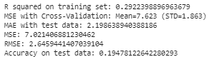
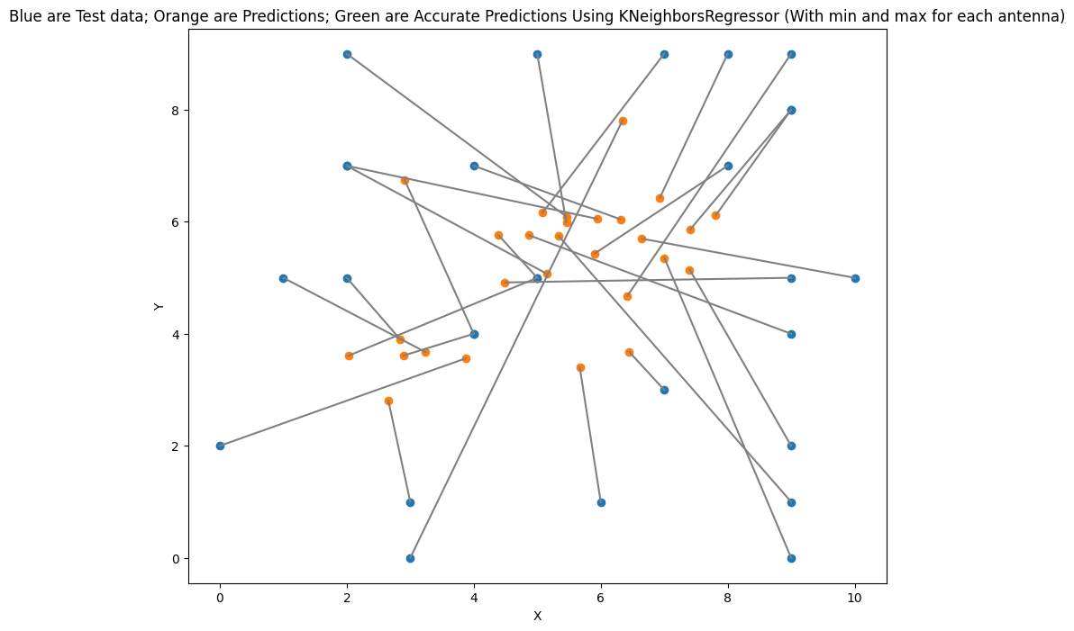

Decision Trees: Useful for classification and regression. They model decisions and their possible consequences as a tree, which is easy to understand and interpret.
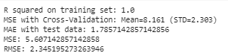

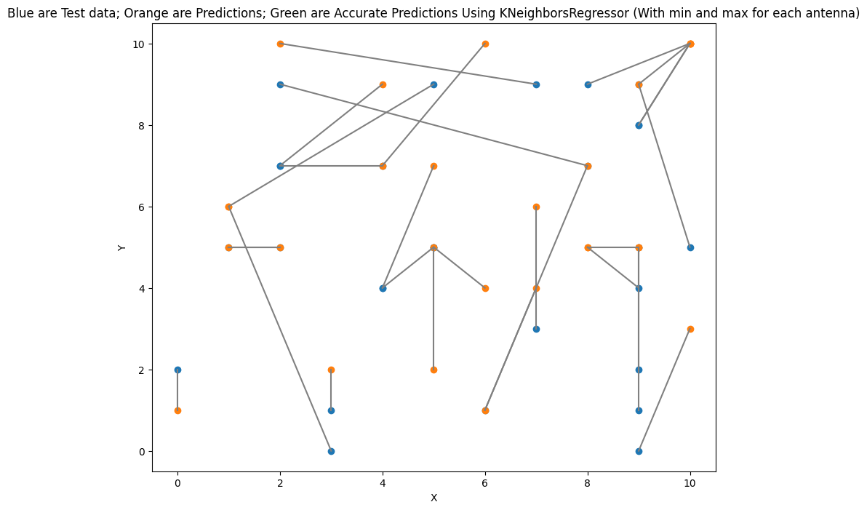
Random Forest: An ensemble of decision trees, typically used for classification problems. It improves model accuracy by reducing overfitting.
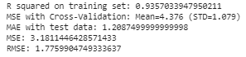
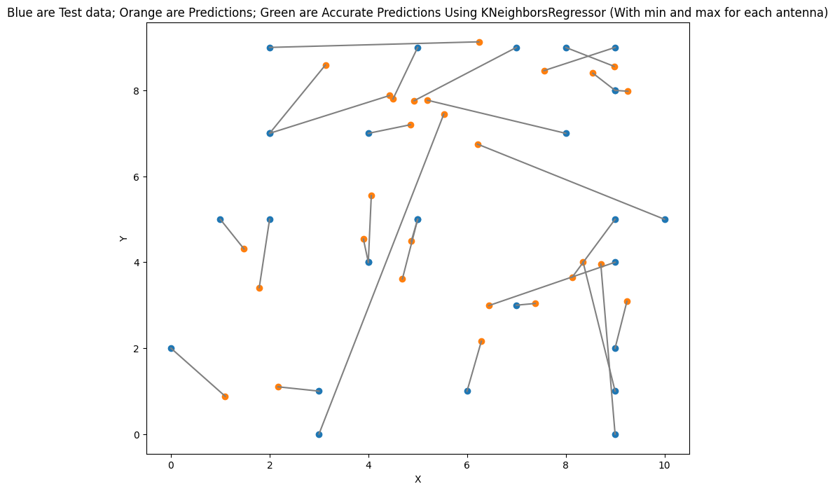

Support Vector Machines (SVM): Effective in high-dimensional spaces and best suited for classification problems, especially binary classification.
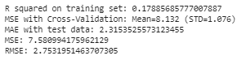
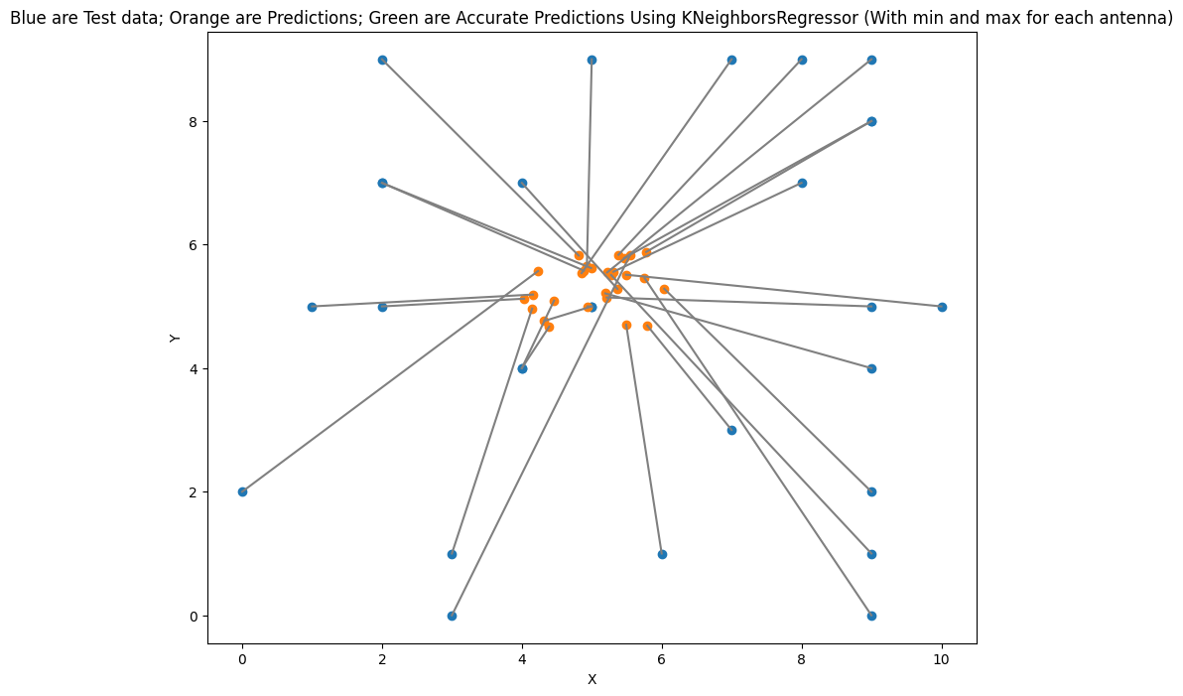

K-Nearest Neighbors (KNN): A simple, instance-based learning algorithm used for classification and regression. It classifies a data point based on how its neighbors are classified.
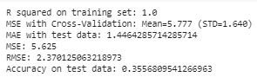
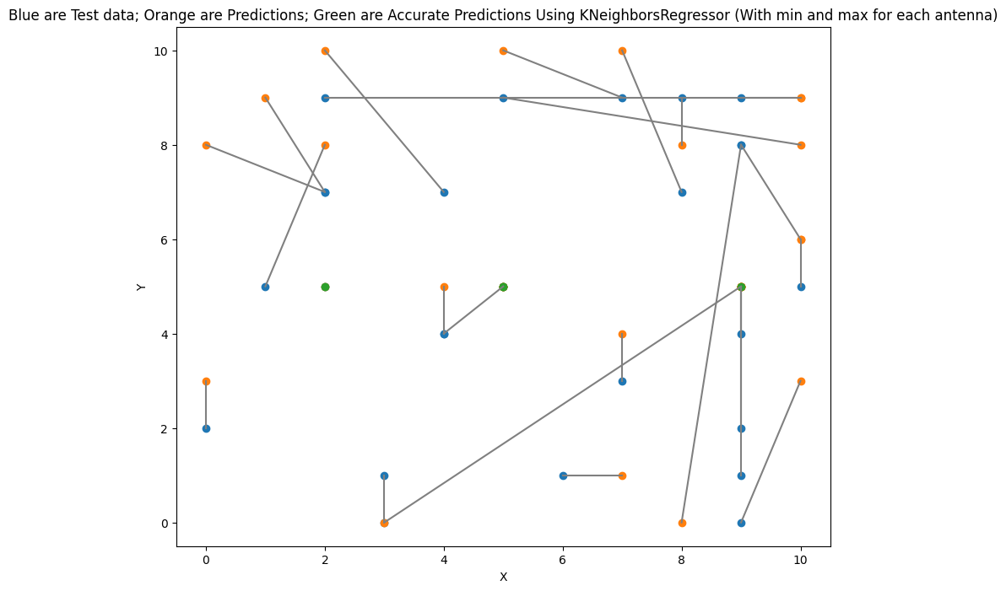

Neural Networks: Highly flexible and capable of modeling complex non-linear relationships. They are especially useful for large datasets.

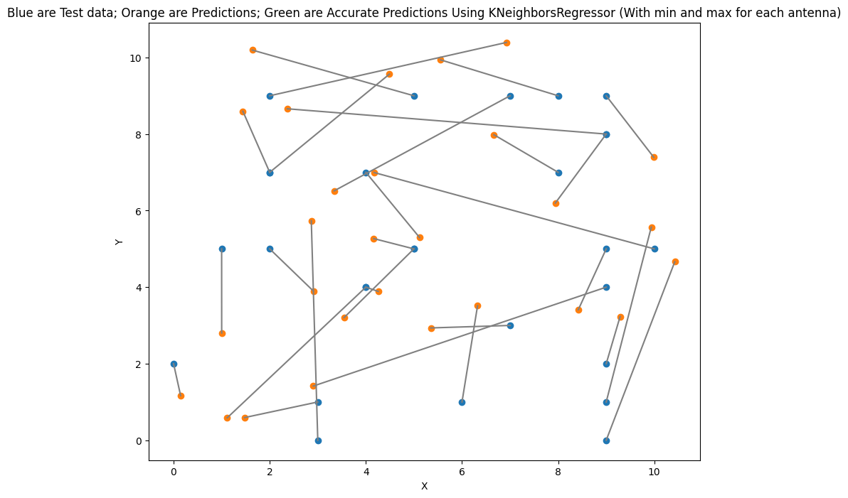
NN Finetune - 4 hours 50 runs
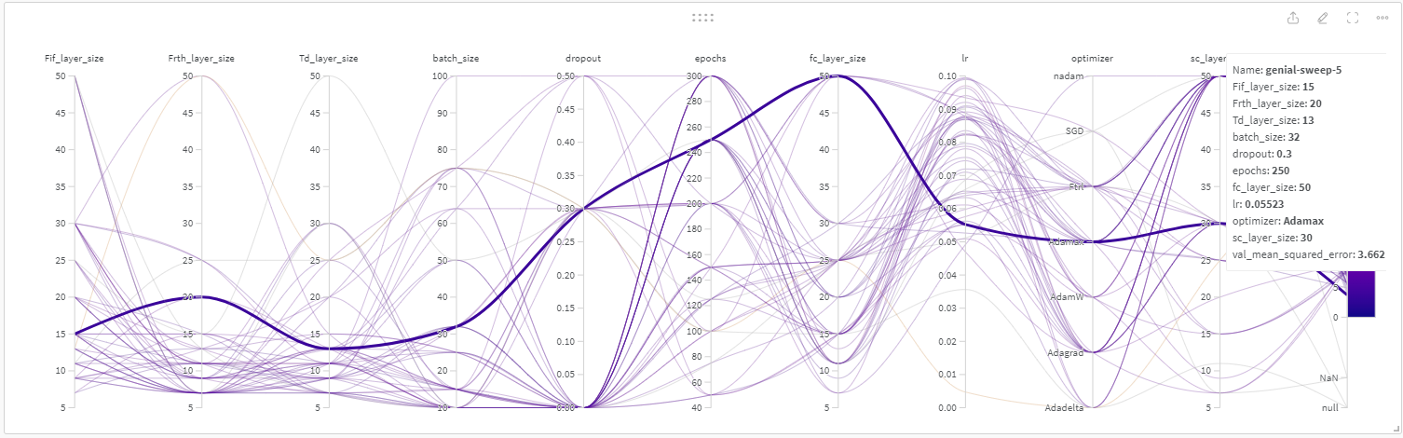
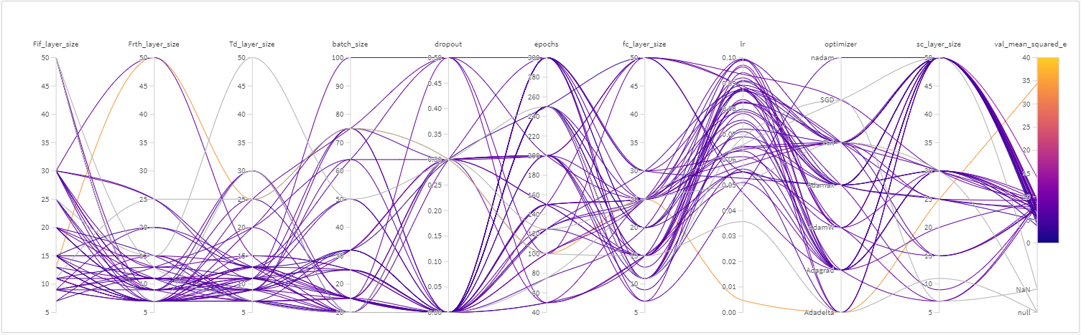

Gradient Boosting Machines (GBM): An ensemble technique that produces a prediction model in the form of an ensemble of weak prediction models, typically decision trees. It's often used for both classification and regression tasks.
